Awakino River & Tasman - Quarterly River Monitoring August
Sample Collection Day: 25th August 2025
Water quality was Excellent in Mangaorongo stream (Site 3).
E. coli concentrations were very low (120 cells per 100 mL), falling well within health guidelines for swimming (540 cells per 100 mL).
Nitrogen: Nitrate concentrations were very low (0.17 mg/L), falling well below the ecological toxicity threshold (2.4 mg/L). Ammonia concentrations were also very low (0.009 mg/L). Dissolved inorganic nitrogen (DIN) was corresponding very low (0.18 mg/L), falling well below the ecological impact threshold (0.5 mg/L).
Phosphorus: Dissolved reactive phosphorus (DRP) was very low (0.003 mg/L).
Suspended sediment/Water Clarity: Water clarity was Excellent (1.45 m), relative to the national bottom line (0.61 m).
The results in the table below have been graded according to the National Policy Statement for Freshwater Management (NPS-FM, 2020).
River Level and Flow Rate – Awakino River Rauroa Farm Bridge
The below chart presents continuous data collected by the Waikato Regional Council for Awakino river between 1st January and 26th August 2025. River Level and Flow Rate on the day of sampling (25-August) are highlighted.
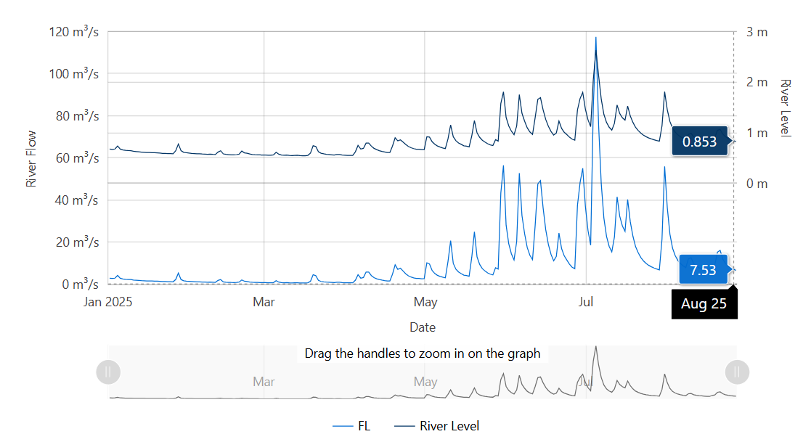
Data source: Waikato Regional Council envirohub website for environmental data.

