Mangaotaki-Mairoa – Quarterly River Monitoring February
Sample Collection Day: 18th February 2025
Water quality was Fair across in Waitanguru stream (Site 10) and Kihikihi stream (Site 30) and Poor in Mangaotaki river (Site 11).
E. coli concentrations were very high across all sites (range = 1,300 to 1,400 cells per 100 mL), exceeding recommended health guidelines for swimming (540 cells per 100 mL).
Nitrogen: Nitrate concentrations were low to moderate across sites (range = 0.45 to 0.56 mg/L), falling well below ecological toxicity levels (2.4 mg/L). Kihikihi stream had the lowest concentration and Mangaotaki river had the highest concentration. Ammonia concentrations were low across all sites (≤ 0.02 mg/L). Dissolved inorganic nitrogen (DIN) was low in Waitanguru stream and Kihikihi stream (≤ 0.5 mg/L), falling just below the ecological impact threshold (0.5 mg/L). Mangaotaki river had slightly elevated DIN (0.58 mg/L).
Phosphorus: Dissolved reactive phosphorus (DRP) concentrations were low in Mangaotaki stream and Kihikihi stream (≤ 0.009 mg/L). Waitanguru stream had slightly elevated DRP (0.011 mg/L).
Suspended sediment/Water Clarity: Water clarity was excellent in Waitanguru stream (3.35 m), good in Kihikihi stream (1.73 m) and poor in Mangaotaki river (1.21 m), relative to the national bottom line (1.34 m).
The results in the table below have been graded according to the National Policy Statement for Freshwater Management (NPS-FM, 2020).

Mokau River – Summary of water quality collected from 15 sites across the Mokau River catchment on 18th February 2025

Most sites had low nutrient levels, but elevated E. coli and poor water clarity were common, with a few locations exceeding human health and ecological health thresholds.

E. coli: 60% of sites had elevated concentrations (between 890 and 3,100 cells per 100 mL), 20% (3 sites) had slightly elevated concentrations (between 300 and 500), and 20% had low concentrations (≤ 170).
Nitrogen: Nitrate: 100% of sites had low concentrations (range = 0.001 to 0.56 mg/L). Ammonia: 100% of sites were low to moderate (range = <0.005 to 0.200 mg/L). Dissolved Inorganic Nitrogen (DIN): 93% of sites had low concentrations (≤ 0.50 mg/L), and 7% (1 site) was slightly elevated (0.58 mg/L), exceeding the ecological impact threshold of 0.5 mg/L.
Phosphorus: Dissolved Reactive Phosphorus (DRP): 80% of sites had low concentrations (between <0.002 and 0.009 mg/L), 13% (2 sites) were slightly elevated (0.011 – 0.012 mg/L), and 7% (1 site) returned a very high concentration (0.024 mg/L).
Suspended Sediment / Water Clarity: 47% of sites had good water clarity (A or B band), 7% (1 site) had fair water clarity (C band), and the remaining 47% had poor water clarity (D band). Bands for each site relate to the National Bottom Line (NBL) for water clarity and depend on landscape characteristics including geology, climate, and elevation. The NBL for Mokau River monitoring sites is either 1.34 m or 0.61 m, depending on local landscape characteristics.

River Level and Flow Rate – Mokau River, Totoro Road
The below chart presents continuous data collected by the Waikato Regional Council for Mokau River between 1st January and 19th February 2025. River Level and Flow Rate on the day of sampling (18-Feb) are highlighted.

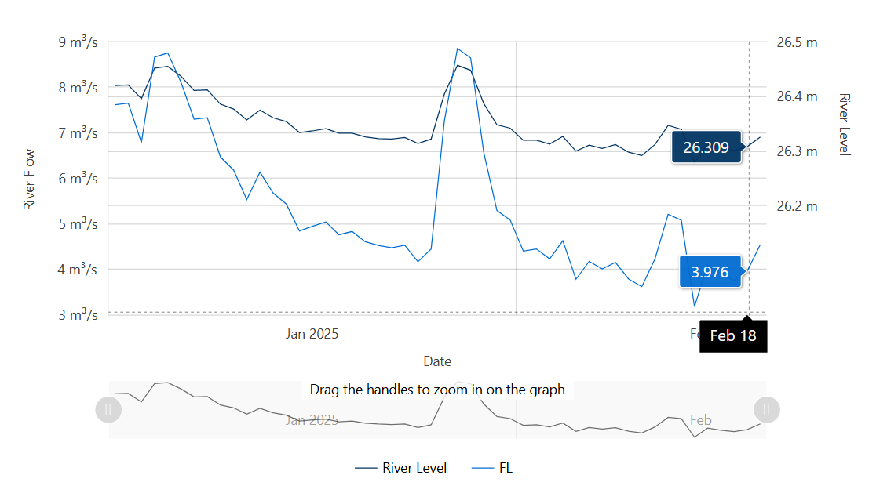
Data source: Waikato Regional Council envirohub website for environmental data.

