Awakino River & Tasman - Quarterly River Monitoring
Sample Collection Day: 12th November 2024
Overall, water quality at Mangaorongo stream was Fair. E. coli was very high and dissolved reactive phosphorus was slightly elevated.
E. coli was very high (5,100), falling above the recommending health levels for swimming (540). Nitrate and Ammonia concentrations were low, falling well below levels which can cause ecological toxicity impacts (Nitrate 2.4 mg/L; Ammonia 0.24 mg/L). Dissolved inorganic nitrogen was low (0.40 mg/L), below concentrations considered as potentially impacting ecological health by promoting excessive growth of algae, aquatic plants and impacting sensitive aquatic species. Dissolved reactive phosphorus was slightly elevated (0.011 mg/L). Water clarity was excellent (0.95 m), relative to the national bottom line (0.61 m), indicating relatively low concentrations of suspended sediment.
River Level and Flow Rate – Awakino River Rauroa Farm Bridge
The below charts present continuous data collected by the Waikato Regional Council for Awakino river between 1st January and 30th November 2024. River Level and Flow Rate on the day of sampling (12-November) are highlighted on the second chart.
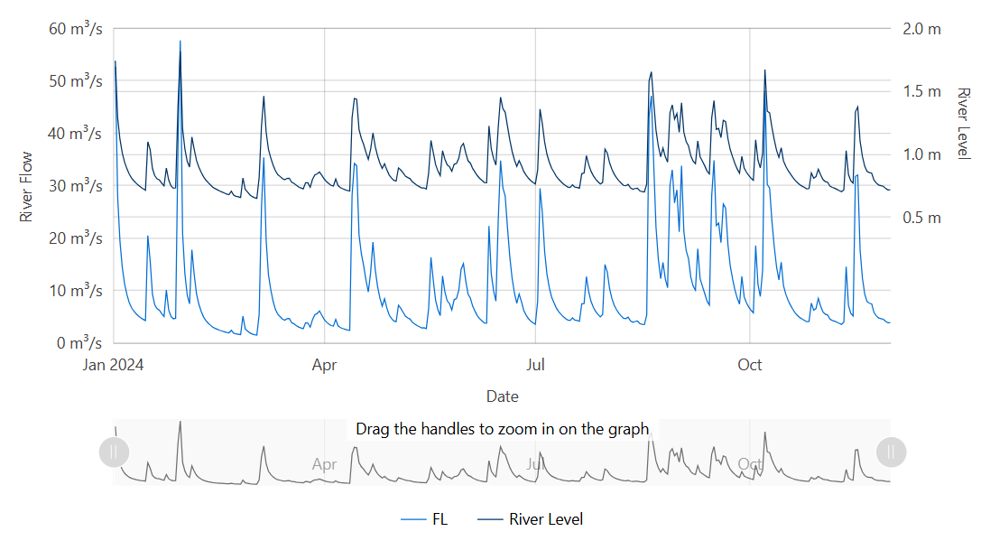
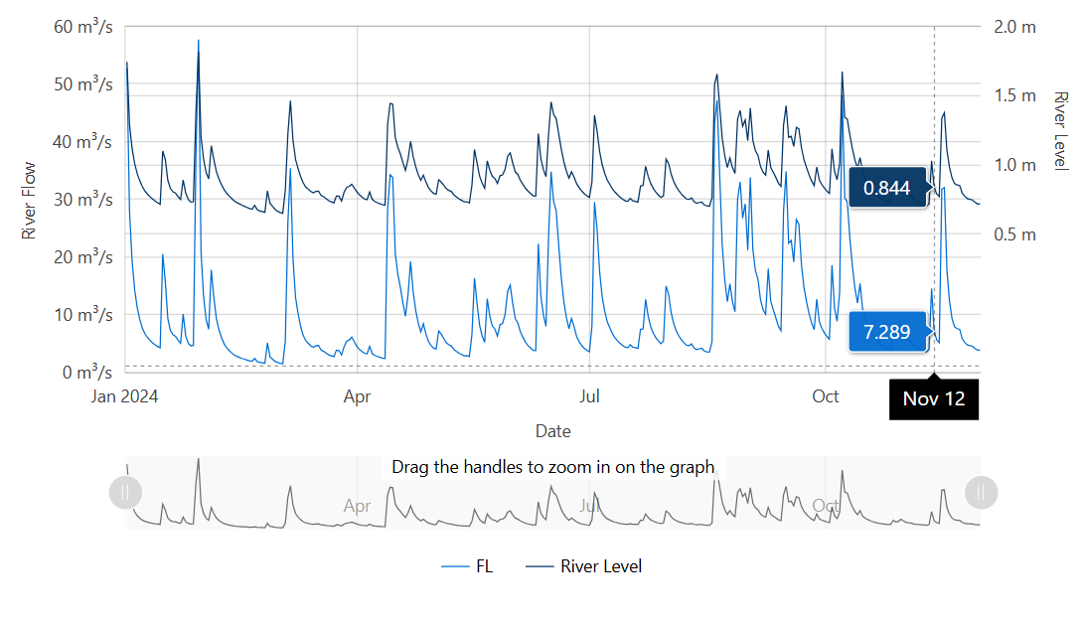
Data source: Waikato Regional Council envirohub website for environmental data.

