Awakino River & Tasman - Quarterly River Monitoring
Sample Collection Day: 26th March 2024
Overall, water quality at Mangaorongo stream was Good, except for E. coli.
E. coli concentrations were elevated (700) above recommending health levels for swimming (540). Nitrate and Ammonia concentrations were well below levels where ecological toxicity impacts occur (Nitrate 2.4 mg/L; Ammonia 0.24 mg/L). Dissolved inorganic nitrogen was low (0.43 mg/L). Dissolved reactive phosphorus was also low (≥ 0.01 mg/L). Water clarity was excellent (1.28 m), relative to the national bottom line (0.61 m), indicating low concentrations of suspended sediment.

Awakino River - Rauroa Farm Bridge - River level
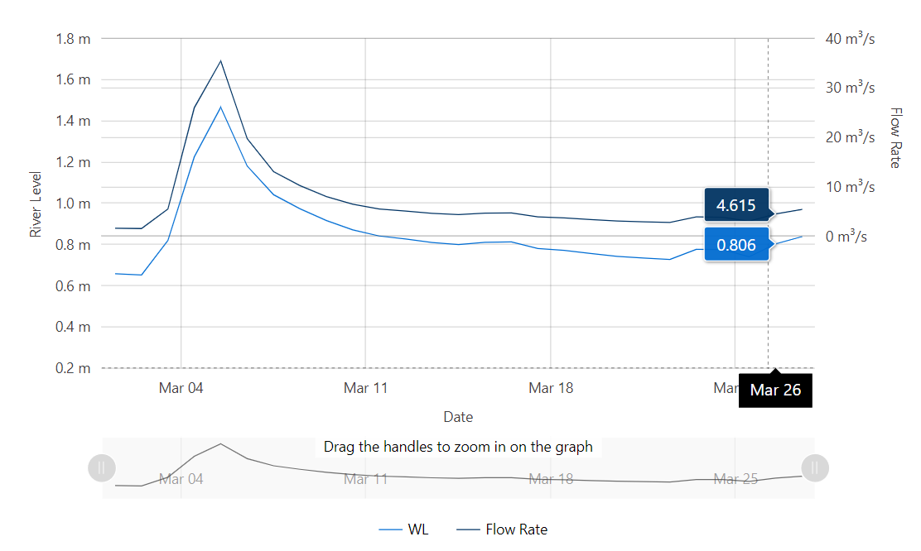
Data source: Waikato Regional Council envirohub website for environmental data.

Ecological impacts, including problematic growth of algae and/or aquatic plants and loss of sensitive aquatic species are likely when the combined concentration of nitrate and ammonia (i.e. DIN) regularly exceed 0.5 mg/L.

