Awakino River & Tasman - Quarterly River Monitoring
Sample Collection Day: 14th November 2023
Overall, water quality at Mangaorongo stream was fair on 14th November 2023.
E. coli concentrations were slightly elevated (350). Nitrate and Ammonia concentrations were well below toxicity levels (Nitrate 0.53 mg/L; Ammonia 0.005 mg/L). Dissolved Inorganic Nitrogen (DIN) was slightly elevated (0.54 mg/L), potentially impacting river health. Dissolved reactive phosphorus was also slightly elevated (≥ 0.013 mg/L). Water clarity was excellent (3.38 m) relative to the national bottom line (0.61 m).

Awakino River - Rauroa Farm Bridge - River level
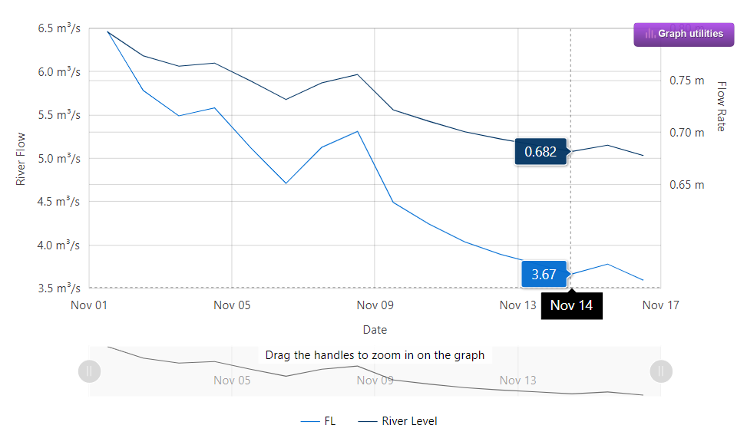
Data source: Waikato Regional Council envirohub website for environmental data.

Ecological impacts, including problematic growth of algae and/or aquatic plants and loss of sensitive aquatic species are likely when the combined concentration of nitrate and ammonia (i.e. DIN) regularly exceed 0.5 mg/L.

